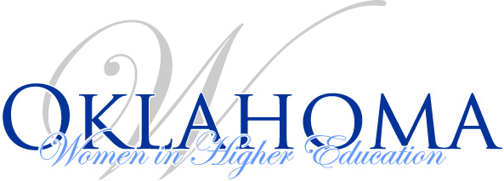
Board Meeting Agenda
October 24, 2019
1 p.m. – 3:00 p.m.
State Regents Offices – 3 South Conference Room

- Approval of Minutes (September 2019)
- Review finance report
- IA News – Kim
- Sponsorships – Debbie
  - Sponsor in name only
  - Update on larger sponsorships
- Report status of Financial Audit – Shirley
- Job Shadow – Shirley
- Review Nomination form and Applications for open EB positions (Stephanie)
- Review communication for applications and nominations for: (Stephanie, Darla, Angel)
  - Governance
  - Spring Conference Chair(s)
  - 4 Year Tier Representative
- Set date for review and selection of new EB members based on release of the nominations and applications. – Karen
- Fall Conference Update (Stephanie & Darla)
  - Turn in door prizes (if have any at this time)
- Other Business
  - ACE Conference March 14 – 16 registration is now open.
- Set next meeting date.
- Other

