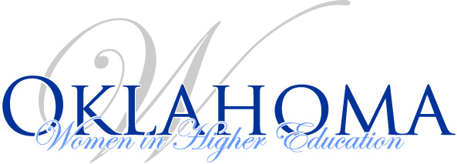
Board Meeting Agenda
April 23, 2020
1 p.m. – 3:00 p.m. (via Zoom)

- Finance Report
- Approval of March 2020 Minutes
- Job Shadow Update
- Debbie Blanke Scholarship update
- Fall 2020 Conference Update
- Website Updates
  - OKWHE State Board Open Positions
  - Updated the “About Us” page (4/15/20)
  - Cannot find “What’s Happening” on the home page??
- Other
  - ACE refund for Conference received

