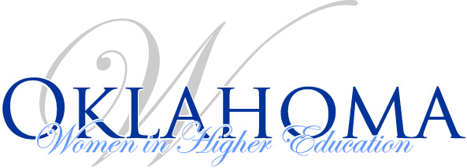
Board Meeting Agenda
February 1, 1 p.m. – 3 p.m.
- 2017 Fall Luncheon comments or suggestions

- Finance report

- IA news

- OKWHE State Board Secretary Interests (I had two requests for this spot on our board):
  - Catherine Orozco-Christmas, Accreditation Specialist, Oklahoma State Accrediting Agency
  - Melissa Brevetti, Ph.D., Director of Clinical Partnerships, Langston University
  - Sarah Wyatt, Assistant Director Student Success, Retention, and Inclusion, Tulsa University
  - Elisabeth Ponce-Garcia, Assistant Professor of Psychology, Cameron University
  - Monique Bruner, Director, Degree Completion and Student Retention, Rose State College
  - Darla Fent-Kelly, CEPS Asst. Dean & KHS Professor, University of Central Oklahoma

- Spring Luncheon
  - Where
  - When
  - Food
  - Theme
  - Other

- Other

