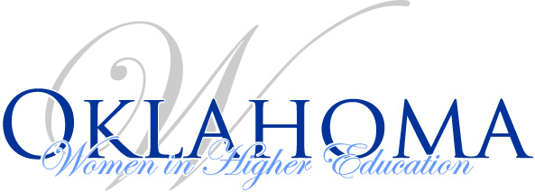
Officer Meeting
Agenda
January 19, 1 p.m. – 3 p.m.
Oklahoma State Regents for Higher Education
Library Conference Room
405-225-9100 ext. 9503

- 2017 Fall Luncheon comments or suggestions

- Finance report

- IA news (if any)

- OKWHE State Board Secretary Interests (I had two requests for this spot on our board):
  - Catherine Orozco-Christmas, Accreditation Specialist, Oklahoma State Accrediting Agency

  - Melissa Brevetti, Ph.D., Director of Clinical Partnerships, Langston University

- Spring Luncheon
  - Where
  - When
  - Food
  - Theme
  - Other

- Other

